**Software development lifecycle**

Planning

**Technical Requirements**

The senior developer has provided you with the following technical requirements for the project.

* The Ticket class should contain common ticket information in the Ticket class.
* The Ticket class should also have method allowing the staff to submit ticket and the IT team to respond to the tickets, specifically resolve, reopen and provide a response to the ticket.
* The Ticket class should contain a method for resolving password change requests. As well as calling the method that would generate the new password, it should set up a response for the ticket and change the ticket status to closed.
* There should be a method to print information for all the ticket objects.
* The Ticket Stats method in Ticket class should contain information on ticket statistics and shall be able to return the statistics information.
* The main class, containing the Main method.
* Create at least one instance of submitting tickets and include at least one ticket with the request of “Password change”.
* After the tickets are created, display ticket statistics.
* Resolve some of the tickets, then display the ticket information and ticket statistics. Reopen some of the resolved tickets, then display the ticket information and ticket statistics.

Analysis

* In the program the class Ticket is used to hold a person’s details in a ticket form as an object. There is also a static field in the class to retain the statistics of all the tickets created, reopened and resolved, there are multiple functions within the class to make it work. A while Loop is used for the menu and has options from 1-6 with options
* 1. Create new ticket
* 2. Resolve ticket
* 3. Reopen a ticket
* 4. Print all tickets
* 5. Print ticket statistics
* 6. Exit

solution design

* The software that I have used to create this program is Visual studio code and using the programming language python they are both free to download and can be used by anyone for future developments in the program.
* Python version 3.11.0
* Visual studio code 1.73.1

Solution development

* To create this program, we needed to learn how to use classes and loops.
* The classes are used to retain the ticket information and details about the person.
* The while loop is used for the menu and will run until (6) is entered which will then break the loop.
* A counter is used to keep the statistics (Number of Tickets)
* A class is used to hold the ticket information and to make them interactable with the use of functions
* A static method is used when displaying ticket information
* The new password generator uses slicing of strings to create your new password

Testing

This program had to be tested by myself multiple times to ensure the ticket statistics would be added to the counter appropriately and to eliminate any bugs around this. Also testing of the loop to check if it would break when it needed to be and not throw errors.

Screenshots of successful outcomes (Using the Menu)

Example of Password change:

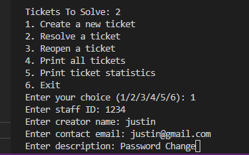

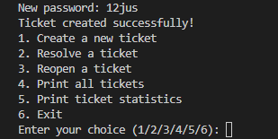

Example of changing ticket statistics:

Example of Ticket List: